Utilizing Artificial Intelligence tools to enhance Sustainable Library and Information Science teaching practices among Library and Information Science educators in Federal University of Technology, Minna

Dr. Miriam Ayinda Salubuyi
Federal University of Technology, Minna.
m.salubuyi@futminna.edu.ng ; +2348034062394

Dr. Fatimah Jibril Abduldayan
Federal University of Technology, Minna.
fj.dayan@futminna.edu.ng; +2347068155501

Comfort Adeline Uno
Federal University of Technology, Minna.
comfort.uno@futminna.edu.ng ;+2348108881962

Abstract
This study investigated the integration of AI tools to improve sustainable teaching practices among Library and Information Science (LIS) educators at Federal University of Technology (FUT), Minna. To carry out this research, purposive sampling was used to gather the necessary data. Four research questions were formulated for the study. Total enumeration was used to adopt the total population of Twenty (20) LIS academic staff in FUT, Minna. A close ended electronic questionnaire was developed which was used to collect data for this study to assess the effectiveness of AI tools in enhancing instructional methods, resource management, and student engagement. The data gathered from the questionnaire were analyzed using descriptive statistics of percentages and charts. Data collected from LIS faculty members reveals that AI tools significantly contribute to the optimization of course delivery, personalized learning experiences, and efficient resource allocation. The findings underscore the potential of AI technologies to support sustainable teaching practices, addressing both pedagogical and environmental concerns in higher education. This research provides actionable insights for LIS educators seeking to adopt AI-driven strategies for advancing teaching practices in alignment with sustainable development goals.
Keywords: artificial intelligence, teaching practices, educators, library and information science.

Introduction
Artificial intelligence (AI) is the term used to describe how technology, particularly computer systems, mimic human intelligence processes. Applications of artificial intelligence include expert systems, machine learning, speech recognition, and natural language processing (NLP). Poutre(2024) stated that, AI systems typically work by taking in enormous amounts of labeled training data, examining it for correlations and patterns, and then utilizing these patterns to predict future states.
The use of AI has grown in many different business domains and scientific domains. Some of the most notable examples are listed below: Industry and commerce, healthcare, banking and finance, law, media and entertainment, journalism, software development, IT, security, manufacturing, transportation, and education. According to Lin (2022), there are numerous ways artificial intelligence (AI) can be used in education - teachers' time can be better used for other tasks by having some of the grading process automated. The author further noted that, AI technologies may also assess how well students are performing and modify to suit their individual needs, enabling more individualized instruction that allows students to work at their own speed. The job of educators may change if AI tutors help students stay on course and modify their learning style.
According to Xue and Wang (2022), educational establishments worldwide have incorporated contemporary technologies in the last fifteen years to enhance the learning environment for instructors and students alike. This means that the shift from blackboard teaching to interactive online classes with smartboards has been notable, with the worldwide pandemic speeding up progress. Automation of tedious jobs and streamlining of procedures in sectors like marketing and healthcare have made headlines due to AI adoption. Educators in any field, from primary school teachers to university professors, can benefit greatly from artificial intelligence. Finding the ideal AI assistant can be revolutionary, as educators are always juggling a lot of jobs.
There is no longer any question about the fact that technology and other advances in our society have had a profound and enormous impact on library and information science (LIS) education around the world. To put it another way, Abubakar (2021) noted that, there have been significant changes to LIS education, particularly in the previous several decades, leading to alterations in all of its structures. These kinds of shifts are global, widespread, and profound. Additionally, the field of LIS is now viewed as an interdisciplinary field of study that has integrated many new and related areas such as information science, computer science, information system, knowledge management, information architecture, digitization, content management, and archives related areas. Therefore, it is crucial to emphasize that expanding and altering LIS programs to fit the new, changing environment—especially in the domain of ICTs and AI—is now inevitable.

Statement of the Problem
Although the use of Artificial Intelligence (AI) tools in educational contexts has the potential to revolutionize teaching methods, their application in Library and Information Science (LIS) education has not yet reached its full potential. The adoption and implementation of sustainable teaching approaches that capitalize on contemporary technological breakthroughs presents challenges for LIS educators at FUT Minna. The issue is that, even though AI tools have the potential to improve sustainability and efficacy of instruction, the LIS department lacks a thorough grasp of and experience with these tools in real settings. Abubakar (2021)explained that, this disparity makes it more difficult to create creative teaching methods and maximize learning results in the discipline of library and information science. In order to solve this problem, it is necessary to investigate the ways in which LIS educators may support and enhance sustainable teaching techniques by leveraging AI tools.

Literature Review
A transformative era for classroom teachers has begun with the introduction of Artificial Intelligence (AI), which has opened up a new world of possibilities in the teaching and educational sectors. This advancement in technology brings with it a set of AI-driven technologies that improve the delivery of instructional materials while also streamlining administrative duties Elgohary & Al-Dossary (2022). AI technologies for educators have a wide range of uses, from making interesting and interactive presentations to producing accurate assessment questions and real-time feedback. By providing them with supplementary resources to enhance conventional teaching materials, these technologies aim to assist classroom teachers. Teachers can adapt their methods to each student by integrating AI, making sure that every learner gets the support and individualized instruction they need to succeed.

According to Lin (2022), Artificial intelligence (AI) technologies also make it easier to create critical thinking exercises and challenging questions that push students' comprehension limits and encourage a deeper engagement with the material. Furthermore, they also make it possible to automate repetitive tasks like assignment grading, which frees up teachers to concentrate more on teaching and less on paperwork.

Several special aspects of AI tools can support teachers in their instructional duties. A few of these AI capabilities as listed by Edutopia (2024) include,
Simplified workspace: Search for an AI teaching assistant program that offers a single location to store all of your resources, such as lesson plans, educational materials, student information, and all AI-generated content, for convenient access.
Features for collaboration: Select capabilities such as real-time editing, ideating, commenting, and file sharing that facilitate live collaboration and foster teamwork and communication.
Tools for organization: To assist you with work prioritization and classification, look for AI-powered solutions with strong organizational features like tagging and filtering.
Features for time management: Make sure the AI tool has time-tracking, progress-tracking, and deadline reminders so you can increase productivity and concentrate on the important things.
Composing and recording features: To easily produce, edit, and distribute work products, use programs with integrated writing and documenting features, such as note-taking, editing, and pre-built templates.
Artificial Intelligence Generation: Use generative AI techniques to produce interesting lectures, presentations, and activity ideas that will boost teaching creativity and effectiveness.

Top 10 AI Tools for Educators to Use
Edutopia (2024) listed the top ten AI tools for educators’ use as,
1. ClickUp
Ideal for managing, producing, and collaborating as a team. Educators may avoid the hassles of managing several work management, collaboration, and communication tools by using ClickUp, an all-in-one productivity platform. The software Click Up for Education is great for handling academic and administrative responsibilities in one interface, like monitoring students’ information and developing curricula. Additional Clickup features include,
- Quick responses: Obtain lesson plans, student information, and study materials quickly without having to go through papers on the ClickUp site by hand.
- Organizing and planning: Enhanced organizational skills allow you to organize classes, manage assignments, make to-do lists, grade assignments on time, and share papers with students.
- Automated updates: Avoid wasting time on manual tracking by receiving automated progress reports on chores like grading documents and submitting assignments.
- Project synopses: Provide thorough project summaries that include goals, schedules, and deadlines for efficient planning.
- Writing support: Get AI-powered writing support to produce detailed lesson plans and rich tables containing student data, come up with ideas for classroom activities, and correct spelling errors to boost productivity.

2. Twee
Most effective for understanding YouTube videos and producing instructional materials. One well-liked AI tool for instructors to use in lesson planning is Twee. It can be used for other courses as well, even though its primary purpose is to support English teachers. Twee can assist with reading comprehension, writing prompts, vocabulary development, speaking practice, listening exercises, and grammar exercises thanks to its artificial intelligence capabilities.
With Twee, instructional materials including letters, stories, dialogues, multiple-choice questions, true/false questions, and articles can be created. Time-constrained educators may construct interesting English classes quickly with Twee's special YouTube video tool. The top qualities of Twee include;
- Write content for many subjects, such as articles, stories, and dialogues.
- Create activities, summaries, and questions straight from YouTube videos.
- Arrange lesson plans and provide them to students in PDF format.

3. Lumen5
Using artificial intelligence, Lumen5 is an internet application for creating videos from written content. It is a great tool for educators and professors who, when slideshows fall flat, need to quickly produce polished yet interesting movies. Lumen5 provides tools to resize and compress videos, combine clips, add text to videos, and more. It can be used by educators to make instructional materials for pupils, crucial presentations, and notices for the school. The greatest things of Lumen5 are as follows,
- Turn text into interesting videos without the need for complicated video editing tools
- Use a sizable collection of royalty-free photos, films, and music to improve the visuals in your content
- Adjust the generated video by making changes to the text, graphics, audio, and branding aspects.

4. Canva
Educators wishing to create dynamic presentations, lesson plans, visual aids, and more can utilize Canva, a user-friendly and free AI graphic design platform. It contains one of the greatest resource libraries, which includes gifs, movies, animations, and music in addition to templates, infographics, and posters. Canva effortlessly shares and reviews student work straight through your learning management system (LMS) by integrating with popular classroom technologies like Google Classroom and Microsoft Teams (Coursera, 2024). Among Canva's greatest features are the following,
- Select from thousands of pre-made templates to save time browsing
- It can be connected with Google Classroom to share work with others.

5. Audio Pen
Excellent for writing instructional materials. Taking notes and creating content is made easier with AudioPen, an easy-to-use AI voice-to-text tool. It's an excellent tool for teachers because it can copy meetings, lectures, and thoughts, which lessens their labor. It even improves readability by getting rid of repeats and stutters. Non-native English speakers may now access education without worrying about making grammatical errors and express themselves in English while on the road because it is compatible with computers and smartphones. (Simplilearn, 2024). The greatest benefits of AudioPen are as follows,
- Record everything, including emails, lesson plans, lecture notes, and student feedback
- The premium edition allows for quickly creation of succinct summaries of extensive recordings, up to 15 minutes.
- Convert spoken narratives into many languages, record research notes with ease while on the go, and transcribe meetings.

6. OpenAI ChatGPT
Ideal for conducting research and producing content. Many educational uses are possible for OpenAI's potent ChatGPT (Generative Pre-trained Transformer) AI model. For educators, it's the perfect AI tool. With the free edition of ChatGPT, tests, quizzes, and lesson plans are suited to certain subjects, student needs, and learning preferences. It has been one of the most talked-about AI technologies for educators and students since its launch in 2022. Along with creating debate subjects and writing prompts, you can also translate languages—a huge benefit for non-native speakers—and come up with lesson plans for classroom instruction. Teaching with AI is a comprehensive resource provided by OpenAI. This tutorial was created specifically with educators in mind to assist them in using ChatGPT into their teaching environments. It provides teachers with examples, logical justifications, and suggested suggestions for lesson planning. Simplilearn (2024). Among the best features of OpenAI ChatGPT are,
- Provide educational resources with a well-written prompt
- Adjust format and content complexity as necessary.
- Simplify time-consuming chores that repeat themselves, such as grading and making tables with different data.
7. Slidesgo
Ideal for producing educational materials with a visual aid. Slidesgo offers a number of other helpful tools in addition to free Google Slides and PowerPoint templates. These templates are excellent for making presentations or slides for research, planners, notebooks, lessons, meetings, newsletters, thesis defenses, or project proposals. They are available for a variety of industries, including business, marketing, technology, medicine, and even the education department. The "AI icebreaker generator," a tool provided by Slidesgo to educators, is excellent for introducing lessons to students through interactive exercises. One of Slidesgo's biggest benefits is that you can customize classroom templates by adding your own branding, colors, and content.
- Apply AI to supplied content analysis to make content and design recommendations.
- Use Slidego's "AI presentation maker" tool to select the topic, tone, and style; AI will take care of the rest.
- This saves time and effort when creating content from scratch.
8. Microsoft Copilot
Ideal for customizing written content. Microsoft Copilot is an AI application that makes it easy to organize lessons, assign homework, and provide learning resources. The application, which is a Microsoft product, functions similarly to OpenAI's ChatGPT in that it leverages artificial intelligence to perform tasks automatically and produce content in response to your commands. This product facilitates the creation of specialized student feedback, instructional materials, and other resources. One of Microsoft Copilot's biggest advantages is its ability to personalize information for each learner based on their unique learning preferences and needs.
9. Quizizz
Ideal for adaptability and innovation. With the help of Quizizz, a game-based learning platform, teachers and students can engage in fun activities instead of tedious evaluations and reviews. Instructors can utilize this AI tool for free to prepare for tests, provide live lecture, assign homework, conduct individual and group practice, create slides, and more. It is possible to construct interactive tests with leaderboards, avatars, and real-time feedback by utilizing Quizizz AI. Students can use their own devices to complete the quizzes, which come in a variety of question types like multiple-choice, polls, open-ended, and even image-based questions. Coursera (2024) The best features of Quizizz are;
- Make tests with more than fifteen different question kinds; modify the level of difficulty; proofread for errors; and even create new questions.
- Use the tool for in-class or remote learning activities on any web-enabled device.
- Increase student involvement with gamified features like Team Mode, Leaderboards, and Power-Ups.
10. Claude
Ideal for cutting down on time spent on tedious chores. Human values and social norms are intended to be of concern to Claude. Because of this, it's the perfect AI tool for educators. Instructors and Claude can work together to clarify difficult subjects, develop lesson plans, make interesting exercises, evaluate papers, respond to inquiries, and even come up with original material in response to prompts. Reviewing essays and short answer answers from students can be assisted by Claude. Though it can't give you the final scores, Claude can help you identify areas that need improvement. It may offer helpful criticism on how to raise student achievement. Translation of materials, summarizing of articles and research papers, and poetry writing are some of Claude's strongest traits.

How AI Can Enhance the Work of Educators
Personalized learning: Using AI-driven data, teachers may create customized learning experiences that offer insightful information about student performance and learning patterns. AI is able to rapidly modify student learning materials based on this data. Personalized learning experiences that take into account each student's learning style, learning limitations, and strengths can then be created by teachers using this information. (Stryker & Kavlakoglu, 2024)
Efficiency and productivity: Increased productivity is another benefit of AI as noted by Patrizio (2024). Among the many clerical duties that educators have to perform are interacting with students and their families, marking tests, and giving feedback. Teachers could discover that they spend more time on these administrative duties than they do in instructing and interacting with students.

By automating or streamlining these processes, artificial intelligence (AI) solutions free up more time for teachers to spend with their students.
Content creation and augmentation: Instructors can select from a variety of educational resources by using AI-powered platforms. Especially with generative AI, educators may generate lectures, exercises, quizzes, conversation starters, and presentations with just a brief keyword-based suggestion Gatlin (2023).
Computerized Lesson Plans: Instructors are always looking for ways to make class planning more organized and efficient. Due to this endeavor, lesson planning platforms have been created with the intention of reducing the difficulties teachers encounter when creating and adjusting extensive lesson plans. This platform efficiently expedites the planning process by developing an automated approach for lesson plan generation, allowing teachers to save valuable time. Gatlin (2023).
Improving the adoption and effective use of AI tools among LIS (Library and Information Science) educators at FUT Minna can be achieved through a combination of strategies:
1. Training and Professional Development: Provide workshops and specialized training on AI tools. This could involve webinars, in-person instruction, and courses covering the fundamentals as well as more complex aspects of the AI technologies pertinent to LIS.
2. Value Demonstration: Provide real-world examples of how AI tools might improve instruction, research, and library administration. Their advantages can be demonstrated by case studies and success stories from other universities.
3. Integration into Curriculum: Include AI technologies in the LIS curriculum so that teachers can learn how to use them in their lesson plans and homework.
Provide continuous technical support and resources, including FAQs, manuals, and troubleshooting assistance. Having a committed support staff or a person to contact with questions about AI might allay worries.
5. Promote Collaboration: Create a cooperative atmosphere where teachers can exchange best practices and their experiences with AI tools. Establishing discussion boards, communities of practice, or forums can help in knowledge sharing.
6. Feedback Mechanism: Put in place a method for getting teachers' opinions about the AI technologies. Utilize these comments to address any issues that come up and to make improvements.
7. Pilot Programs: To introduce AI technologies in a controlled way, begin with pilot programs. This enables experimentation and modification in response to preliminary findings and teacher input.

8. Promote incentives: Give educators who actively engage with and effectively use AI tools incentives like grants, recognition, or professional development credits.
9. Leadership Support: Make sure that institutional leadership promotes the use of AI and is in favor of its integration. Support from the top ranks can supply the tools and credibility required for adoption initiatives.

Problems with Artificial Intelligence in Education
There must be Pros and Cons for everything in this world to be in balance, and artificial intelligence is no different. The most frequent difficulties in incorporating AI into LIS teaching methodologies according to Du Boulay (2016), are as follows,

Endangering Teachers' Job Security
The threats to teachers' job security are at the top of the list. Though this hasn't happened yet, it's a worry that the development and application of AI may affect the demand for specific educational job categories. With AI continuing to automate more parts of the educational process, there might be less need for human educators, which could result in increased productivity as well as possible job losses.

Dehumanized educational experience
The potential for AI to dehumanize learning is one of the main drawbacks for educators. Students might not receive the nuanced instruction that a human teacher can provide if AI algorithms are in charge of creating the content and setting the lesson's pace. Furthermore, bias can be reinforced by AI algorithms, which means that they might not be able to offer a diverse, inclusive curriculum that is adapted to each student's needs.

Expensive for Teachers to Adopt
The fact that implementing AI in the classroom might be expensive for instructors is another drawback. Not every educational organization, including schools, has a set amount set aside just for purchasing AI tools and technology. Furthermore, it might be too expensive right now to introduce AI in schools on a large scale. It might be costly and difficult to maintain if the teacher is the one paying for it.
Technology over Dependence
Teachers and students run the risk of becoming overly dependent on technology as schools rely more and more on AI-powered solutions. Long-term, this reliance may lead to the disregard for crucial conventional teaching techniques as well as the failure to foster critical thinking and problem-solving abilities.
Methodology
This study employed a descriptive survey research design. The population of the study is made up of 20 academic staff in Library and Information Science Department, FUT, Minna. Total enumeration was used to adopt the total population of Twenty (20) LIS academic staff in FUT, Minna. A close ended electronic questionnaire was developed which was used to collect data from LIS academic staff. The data gathered from the questionnaire were analyzed using descriptive statistics of percentages and charts.

Results
Table 1.1 Response rate
Table 1.2 Response rate of Respondents
 | Total Number (F%) | Response Rate (F%)
LIS Academic Staff | 20 (100%) | 16 (80%)

Demographic results
Figure 1.1 Depicting the years of service of the respondents
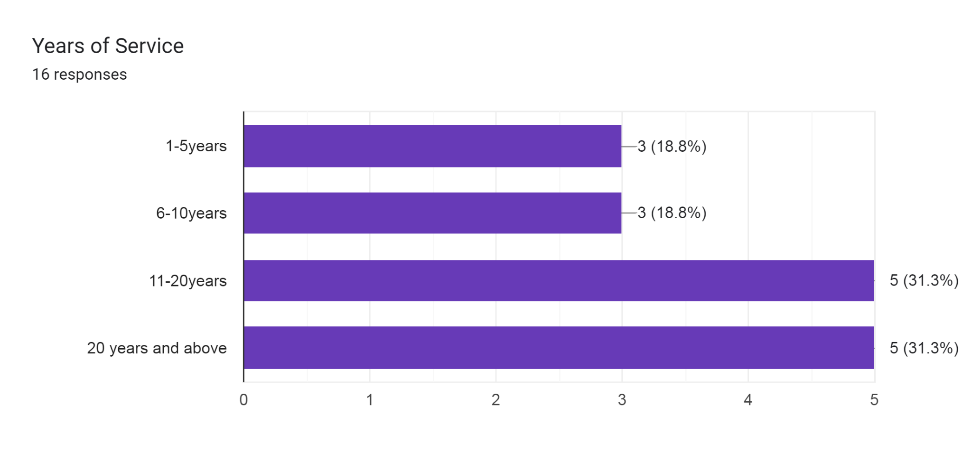
From the figure 1.1, 3 (18.8%) of LIS educators have 1-5 years teaching experience, 3(18.8%) have 6-10 years teaching experience, 5 (31.3%) have 11-20 years teaching experience, while, 5 (31.3%) have 20 years and above teaching experience. This accounts for the wealth of knoelwedge and experience in the department.

Figure 1.2 Depicting the Gender distribution of the respondents
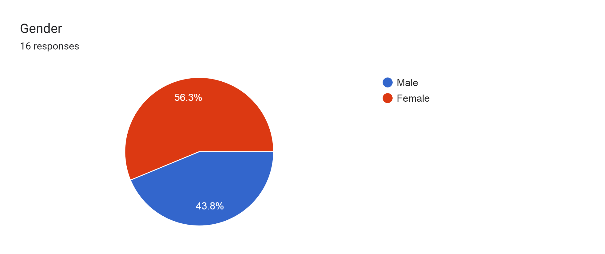

From the figure 1.2, 9 (56.3%) of the respondents are female, while, 7 (43.8%) of the respondents are male.
Figure 1.3 Depicting the professional level of the Respondents
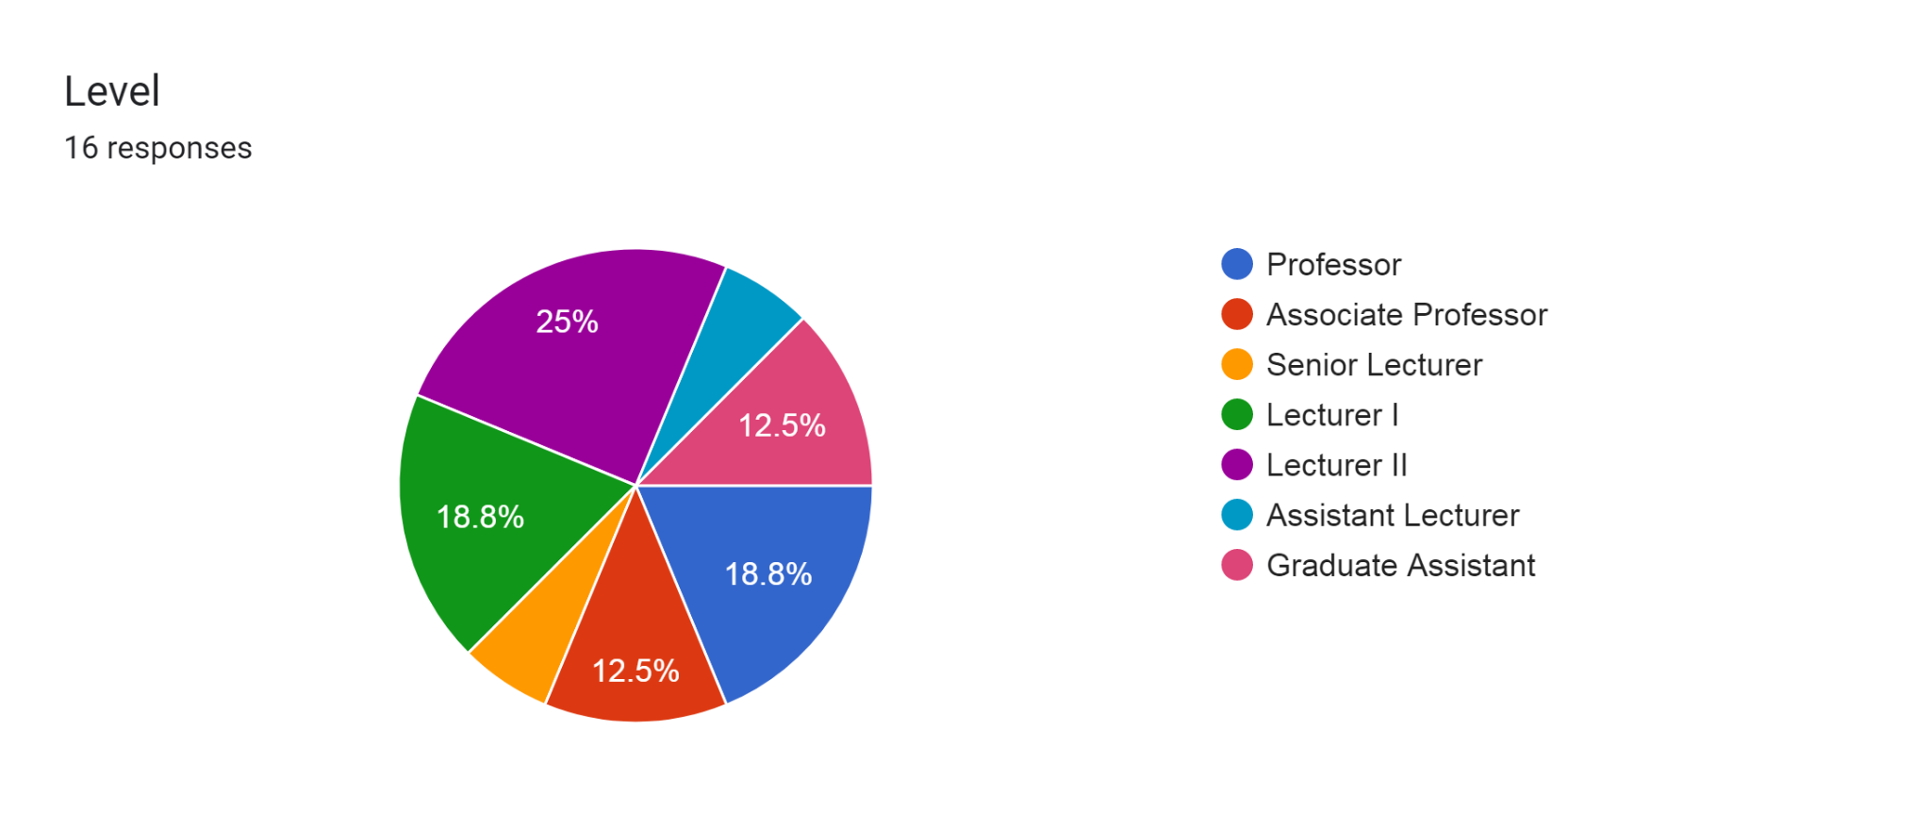
From the Figure1.3, 3 (18.8%) of the respondents were Professors, 2 (2.5%) were Associate Professors, 3(18.8%) were Lecturer I, while, 4 (25%) were Lecturer II

Figure 1.4 Depicting responses for types of AI tools currently used by the respondents
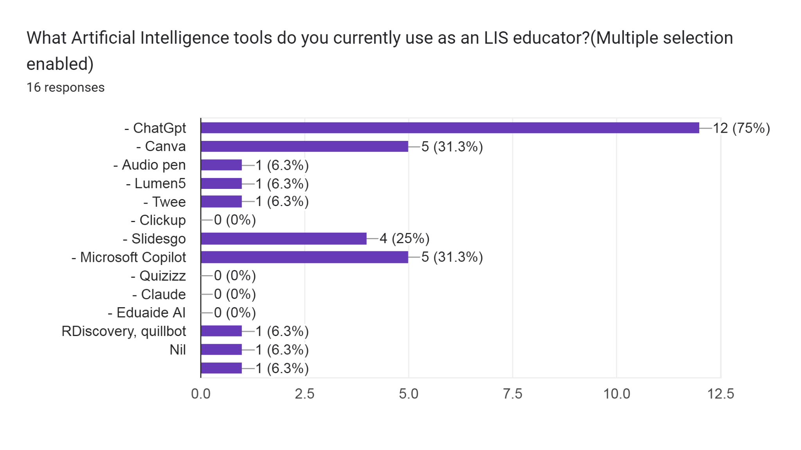
The Figure 1.4 showed ChatGpt as the AI tool mostly used by LIS educators with 12(75%), followed by canva and microsoft copilot with 5(31.3%) each, slidesgo had 4 (25%) , Audio pen, Lumen and Twee all had 1(6.3%). Clickup, Quizizz, claude, and Eduaide AI had 0% while R discovery and quillbot both had 1 (6.3%) respectively.

Figure 1.5 depicting the Influence of AI on different aspects LIS teaching practices.
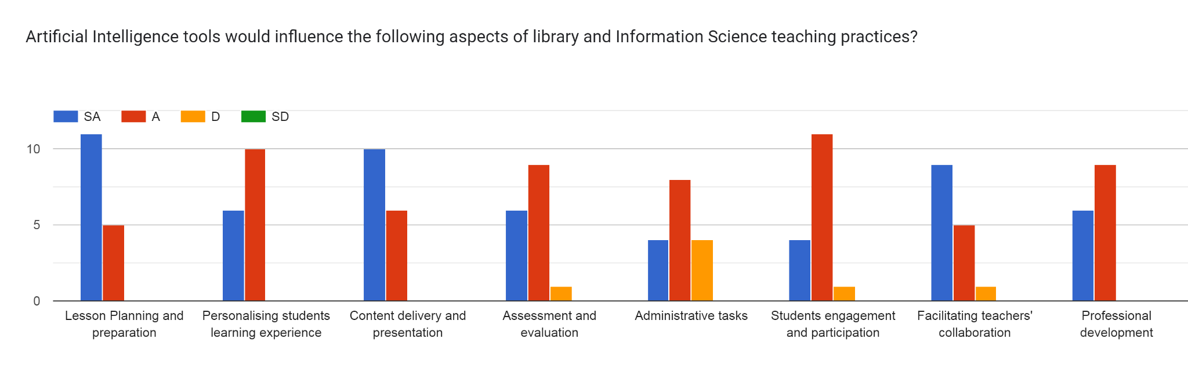
The result in Figure 1.5 shows 68.75% of the respondents strongly agreed that artificial intelligence tools will influence lesson planning and preparation and 31.23% agreed to same. 37.5% of the respondent strongly agreed that personalising students learning experience would be influenced by AI and 62.5% agreed to same. 62.5% of the respondents strongly agreed that AI would influence content delivery and presentation while, 37.5% agreed to same. 37.5% of the respondents agreed that assessment and evaluation would be influenced by AI, 56.25% agreed while 6.25% disagreed to same. 25% of the respondents agreed that AI would influence administrative task, 50% agreed and 25% disagreed. 25% of the respondents strongly agreed that AI would influence student engagement and participation, 68.75% strongly agreed and 6.25% disagreed to same. 56.25% of the respondents strongly agreed that AI would influence teachers’ collaboration, 31.25% agreed and 6.25% disagreed. 37.5% of the respondents strongly agreed that AI would influence professional development and 56.25% agreed to same. From the forgoing result, it can be deduced that there is more agreement to the positive influence that AI makes to the teaching practices of LIS Staff in FUT, Minna.

Figure 1.6 Depicting how the leadership of FUT,Minna /LIS educators improve the adoption and effective use of AI among LIS educators.
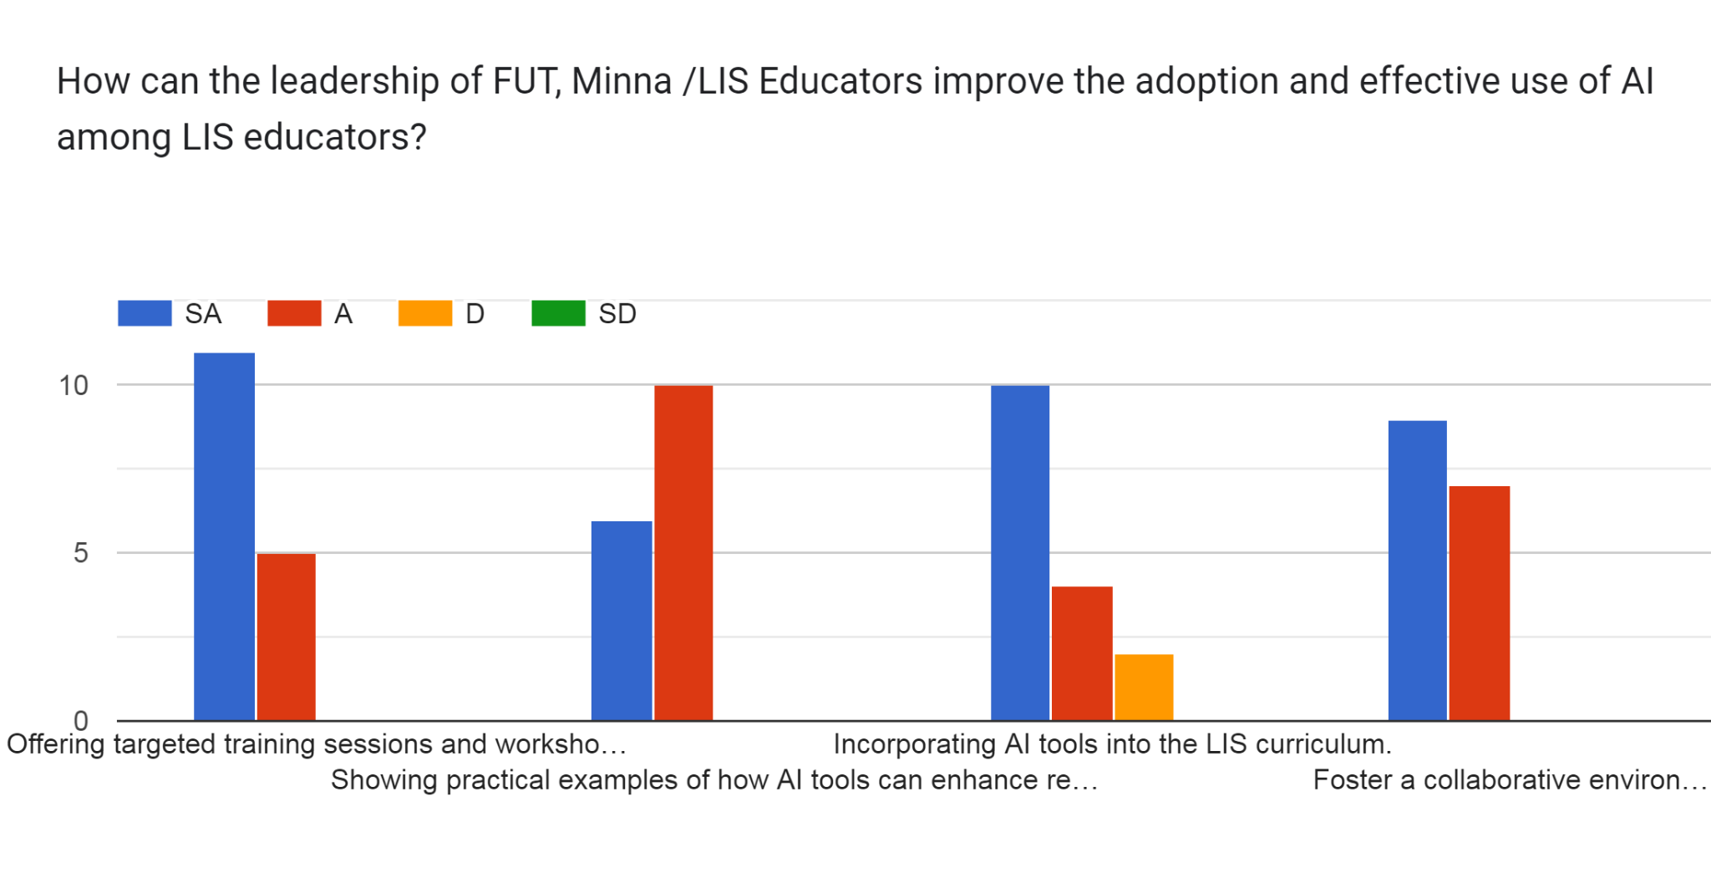
From the above result, 68.75% of the respondents strongly agreed that offering targetted training sessions and workshops can improve adoption and use of AI, 31.25% agreed to same. 37.5% of the respondents strongly agreed that showing practical examples of how AI tools can enhance research and teaching practices can improve AI adoption and 62.5% agreed to same. 62.5% of the respondents strongly agreed that incorporating AI tools into LIS curriculum can improve AI adoption and use, 25% agreed while 12.5% disagreed to same. 56.25% of the respondents strongly agreed that fostering a collaborative environment can improve AI adoption and use while 43.75% agreed to same. This result proves that the school’s authority/ leaderdership of LIS educators have a very important role to play in the adoption and effective use of AI by LIS educators.

Figure 1.7 Depicting percieved challenges associated with the use of AI tools by LIS educators.
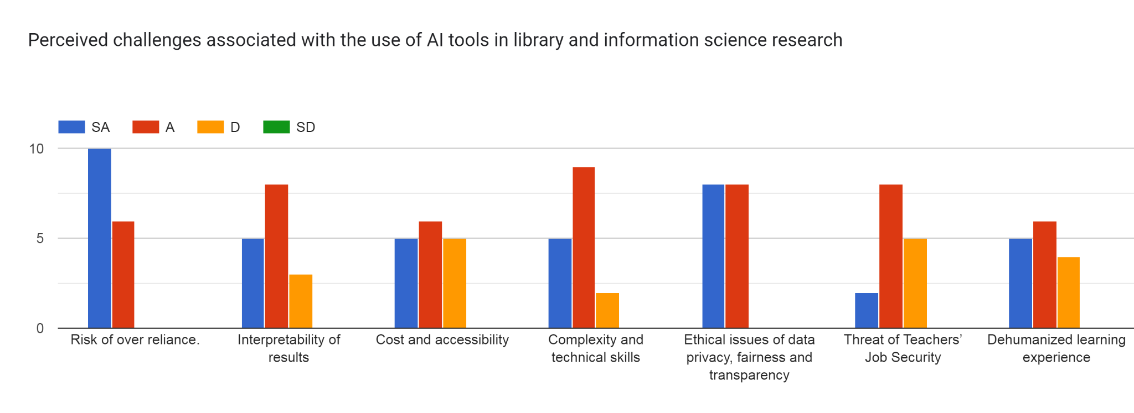
From the result above, 62.5% of the respondents strongly agreed that risk of over reliance is a challenge in the use of AI tools while, 37.5% agreed to same . 31.25% of the respondents strongly agreed that interpretability of results is a challenge in the use of AI tools, 50% agreed and 18.75% disagreed to same. 31.25% of the respondents strongly agreed that cost and accessibility is a challenge in the use of AI tools, 37.5% agreed while, 31.25% to disagreed to same. 31.25% of the respondents strongly agreed that, complexity and technical skills is a challenge in the use of AI tools, 56.25% agreed while, 12.5% disagreed to same. 50% of the respondents strongly agreed that ethical issues are a challenge in the use of AI tools and 50% agreed to same. 75% of the respondents strongly agreed that threat of teachers’ job security is a challenge in the use of AI tools, 50% agreed while, 31.25% disagreed to same. 31.25% of the respondents strongly agreed that dehumanised learning experience is challenge in the use of AI tools, 37.5% agreed and 25% disagreed. This shows that as with anything, challenges also abound in the adoption of AI tools but in all, moderation and control of use is the key.
Recommendations
The Federal University of Technology, Minna's authorities ought to devise tactics that will enable LIS instructors at FUT Minna to become more accustomed to using AI technologies and make efficient use of them in their work.
In co-teaching situations, teachers and AI must work together to provide advice, interpretation, and a deeper level of engagement with the topic. AI systems can help with instruction, evaluation, and real-time feedback and tutoring. Teachers will always play a crucial role as mentors, motivators, and learning facilitators. AI cannot replace the human connection, empathy, social and emotional intelligence, and capacity to nurture creativity and critical thinking that teachers bring to the classroom.
Artificial intelligence (AI) should be utilized sparingly and project a positive image so that students don't become overly dependent on it.

Conclusion
In conclusion, instructors face both opportunities and challenges as a result of AI's growing presence in education. Teachers may use AI to enhance student performance and advance equity in the classroom by adopting a proactive approach towards this technology. This will allow educators to maintain the special role that teachers play in helping students grow, develop, and learn. For this reason, integrating AI-powered EdTech tools into instructors' lesson plans is still essential.

References
Abubakar,M.B. (2021). Library and Information Science (LIS) Education in Nigeria: Emerging Trends, Challenges and Expectations in the Digital Age. Journal of Balkan Libraries Union, 8(1), 57-67. Doi: 10.16918/jblu.932134.

Coursera (2024). What is Artificial Intelligence? Definition, Uses and Types. Retrieved from www.coursera.org/articles/what-is-artificial-intelligence.
Du Boulay, J. B. (2016). Artificial Intelligence as an Effective Classroom Assistant. IEEE Intelligent Systems, 31, 76-81.
Edutopia (2024). 7 AI tools that help teachers work more efficiently https://www.edutopia.org/article/7-ai-tools-that-help-teachers-work-more-efficiently/.
Elgohary, H. K. A., & Al-Dossary, H. K. (2022). The Effectiveness of an Educational Environment Based on Artificial Intelligence Techniques Using Virtual Classrooms on Training Development. International Journal of Instruction, 15(4),1133-1150. Retrieved from www.researchgate.net/publication/364084950.
Gatlin, M. (2023). Assessing Pre-service Teachers’ Attitudes and Perceptions of Using Artificial Intelligence in the Classroom. Texas Educator Preparation.
Lin, H. (2022). Influences of Artificial Intelligence in Education on Teaching Effectiveness: The Mediating Effect of Teachers' Perceptions of Educational Technology. International Journal of Emerging Technologies in Learning (iJET), 17(24).
Poliu,S. (2024). An explanation of different types of AI. Retrieved from www.techtarget.com/whatis/video/ An explanation-of-the-different-types-of-AI
Poutre, S. (2024). Xue, Y., & Wang, Y. (2022). Artificial Intelligence for Education and Teaching. Wireless Communications and Mobile Computing.
Patrizio, A. (2024). Physical AI explained: Everything you need to know. Retrieved from www.techtarget.com/whatis/ physical-AI-explained-everything-you-need-to-know
Stryker, C. & Kavlakoglu, E. (2024). What is AI. Retrieved from www.ibm.com/topics/artificial-intelligence
Simplilearn (2024) Types of artificial intelligence that you should know in 2024. Retrieved from www.simplilearn.com/tutorials/artificial-intelligence-tutorial/types-of-artificial-intelligence.
Xue, Y., & Wang, Y. (2022). Artificial Intelligence for Education and Teaching. Wireless Communications and Mobile Computing. Wireless communications and Mobile computing, 2022(1). Retrieved from onlinelibrary.wiley.com/doi/10.1155/2022/4750018.

