


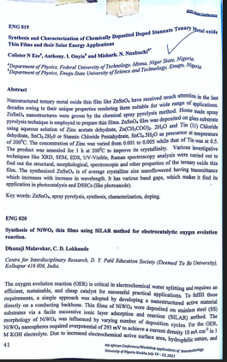

Synthesis and Characterization of Chemically Deposited Doped Stannate Ternary Metal Oxide Thin Films and Their Solar Energy Applications

C.N. Ezeª, A.I. Onyia^{b}, M.N. Nnabuchi^{b*}

ªDepartment of Physics, Faculty of Physical Sciences, Federal University of Technology, Minna, Niger State, Nigeria.
^{b}Department of Industrial Physics, Faculty of Natural Sciences, Enugu State University of

Corresponding author: C.N. Eze
Email: marygodchrist@gmail.com,
Tel.: +2348038711901

Abstract
Nano structured ternary metal oxide thin film like ZnSnO₄ have receive much attention in the last decades owing to their unique properties rendering them suitable for wide range of applications. ZnSnO₄ were grown by the chemical spray pyrolysis method. Home made spray pyrolysis technique is employed to prepared thin films. ZnSnO₄ film was deposited on glas substrate using aqueous solution of zinc acetate dehydrate (Zn (CH₃COO)₂.2H₂O and Tin (11) Chloride dehydrate or Stanic Chloride pentahydrate, SnCl₂.5H₂O as precursor at temperature of 200⁰C. the concentration of Zinc was varied from 0.001 to 0.005 while that of Tin was at 0.5. The product was annealed at 1hr at 200⁰C to improve its crystallinity. Various investigative techniques like XRD, SEM, EDX, UV-Visible, Raman spectroscopy analysis were carried out to find out the structural, morphological, spectroscopic and other properties of the ternary oxide thin film. The synthesized ZnSnO₄ is of average crystalline size nano flowered having transmittance which increases with increase in wavelength. It has various band gaps which makes it find its application in photocatalysis and DSSCs (photoanode).

Keywords: ZnSnO₄, spray pyrolysis, synthesis, characterization, doping.

1.0 Introduction
The amount of energy used up by humanity is greatly rising. This rise is determined by number of inhabitants’ increase and advancement in human progress over the globe. The global energy demands are based on natural resources which are inadequate. These natural energy sources are difficult to arrive at (Agbo, et al. 2006). It can take about a million years to reload. However difficult, it is important to all in all works of life. But of about 7.0 billion people on earth, about 2.0 billion people live without contact with electricity, and about 2.5 billion use wood, charcoal, dung etc as major source of energy. This is chiefly used by non-advanced nations and is not a clean form of energy. It causes pollution. Fossil fuels generally cause global warming and climate change which means an increase in normal global temperatures (Gaurav, Madhungiri, & Karale, 2012).
It is obvious that global stability and sustainability will continuously be troubled by the utilization of fossil fuels. This is the trouble related to these types of energy sources. The escalation of global population, speedy technological expansion and rising energy needs will further complicate this matter. In the existing position of energy crunch and global warming, there is the necessity to build up energy production processes that protract the necessities of sustainability and renewability. There is the need for the vast upgrading in the invention and utilization of renewable energy sources for the provision of adequate energy for people and the safeguard of our immediate environment (Al-Diabat, et al.,2006).
The adoption of the usage of a cleaner form of energy like electricity is the aim of the backward nations. However, this will mean consumption of more energy which will even be greater later as the expected world population from now to 2050 will be around 9.7 billion.
Structures of nanomaterials are different from the bulk materials. These changes made when doping them signifies some hopeful electronic characteristics, such as enhanced light absorption and speedy light response. Among all forms of nanomaterials, one dimensional materials have captivated more responsiveness in electronic device function since they are simple to produce into building blocks and simple to test with two terminals at two ends. Thus, metal oxide nanorods, nanowires, nano-needles and nanotubes are deposited by varieties of processes as they are proper for a big range of functions, like biosensors, smart windows, solar cells, supercapacitors, photodetectors, light-emitting diodes and field effect transistors.
2.0 Solar energy harvesting
It has been proved that energy and environment are among the top list of critical troubles of people as well as civilization even in the next half of 100 years. The tremendous rise in worldwide energy utilization has amplified the exhaustion of fossil fuels. Equally, the burning of fossil fuels results to adverse environmental effects. Mutually, energy and environmental harms prompt worry on the pressing call for seeking substitute renewable and green energy. Renewable energy means any energy supply which can be replaced fast through natural procedure and practically endless, like sunshine ie solar energy, tidal power, wave power, flowing water ie hydro power, biological processes, biofuel, biomass and geothermal heat flows (Sukhatme). Up until now, these types of renewable energy have been tied together by human. Amid these stated renewable energies, solar power draws greater awareness. It is this need for solar energy as a better substitute to fossil fuel that led to fast expansion of solar industry increasing market share for photovoltaic (PV) modules which has been estimated to increase even the more between year 2000 and 2015. If solar cell of 10 % efficiency can cover 0.1% of the earth’s shell, then the world power need can be supplied (Shruti, Kamlosh, & Asutosh, 2015)
The figure below explains the above narration by Nobel Laureate Richard Smally.
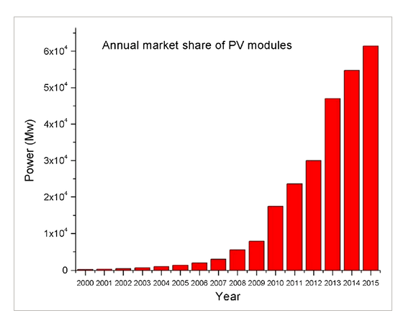
Figure 1: Increasing market share for PV modules from year 2000 to 2015
Fig.2: production of electricity using photovoltaic cells.
Solar energy harvesting could be achieved by the process of doping metal oxide thin films semiconductors with impurities like transition metal oxides, carbon derivatives, synthetic and non synthetic dyes, etc..This will present amazing valuable technique to achieve solar energy harvesting for improved enhancement. This process will require harnessing dopant-induced characteristics and paying attention to control of composition and structure of dopants (Wang & W). On the other hand, deposition of doped nanocrystals with specific control over composition and structure shows a considerable challenge.
Energy harvesting is helpful because it offers techniques of powering electronics when accustomed power sources are deficient. It moreover stops the requirement for changing batteries regularly and connecting wires to end applications. It is appallingly a considerable advance for valuable energy utilization. This is due to the fact that solar energy is a superior option for substituting fossil fuel as the core energy provider. It also follows that solar power is renewable at utterly no payments to offer energy considerably. These renewable energy sources can be used unswervingly to generate additionally other suitable types of energy. Some examples of unswerving utilization are solar ovens, geothermal heating, windmills, etc. The list of indirect exercise, that call for energy harvesting include electricity production using wind turbines, photovoltaic cells or fabrication of fuels like ethanol from biomass (Affrin). Some sources which could be utilized for production of electricity are; Tidal power, wave power and hot hydrogen fusion (Patel, 2016). Nevertheless, every one of the above mentioned method is affected by a major shortcoming or more. This makes it unreliable as a solution to forthcoming energy crisis.
2.1 Solar energy harvesting and Photovoltaic (PV) cells (solar cells):
Most systems, together with wireless sensor networks that harvest solar energy exploit photovoltaic (PV) cells, or solar cells, that change the energy from the sun into utilizable electricity (Arms, Townsend, & Churchill, December,2008). Normally, semiconducting materials like silicon absorb photons when sunlight strikes a PV cell. The energy from the photons liberated electrons that then surge as current due to the occurrence of an electric field that has been created by the separation of charge carriers in the cell. Inserting contacts on the crest and foot of the cell allows DC current to be extracted. Solar energy harvesters exposed to direct sunlight offer the utmost comparative power density of the energy harvesting methods looked at. Nonetheless, a constraint of solar energy harvesting is that the sun will not shine throughout 24 hours in a complete day. Besides, PV cells are current sources and do not supply a stable voltage. So, even with the high power density offered, systems using PV cells need an incorporated energy storage gadget such as a rechargeable battery.
Figure 3: The p-n junction, where the charge carriers are depleted and or accumulated on each side of the surface
When placed on the sun, photons of the sunlight can excite electrons on the p-type side of the semiconductor, a process known as photoexcitation. In silicon, sunlight can provide enough energy to push an electron out of the lower energy valence band, into the higher-energy conduction-band. As the name implies, electrons in the conduction band are free to move about the silicon. When a load is placed across the cell as a whole, these electrons will flow out of the p-type side into the n-type side lose energy while moving through the external circuit and then flow back into the p-type material where they can once again recombine with the valence band hole they left behind. In this way, sunlight creates an electric current. .
3.0 Current technology
stannate perovskite oxides have equally attracted a great deal of interest because of their possible use in the area of solar energy. When a stannate material is illuminated with light, charge carriers (electron-hole pairs) are generated. These photo-generated carriers are seperated and driven to the electrodes by the polarization induced internal electric field, causing a photovoltaic output. The photovoltaic effect in stannate is a bulk-based effect, which differs from the junction based semiconductor photovoltaic effect. Since the internal electrc field is not limited to an interfacial region in a stannates, photovoltaic response can be generated without forming complex junction structures.
The solar cell, otherwise called photovoltaic (PV) cell was developed to change sunlight to electricity via PV effect procedures. In any case, its business in home utilization is restricted due to the expensive and complicated production technique for a usual silicon-based solar cell. It is the bid to cut down this high cost and at the same time retains the efficiency that brought about the production of DSSCs which is a third generation solar cell and other types of solar cells. The 15 % or more efficiency achieved by DSSC was when perovskite was used as sensitizer. Other novel techniques have also got the attention of scholars.
3.1 Types of solar cells:
3.1.1 Semiconductor solar cells:
In semiconductor materials, the majority charge carriers are electrons and the Femi levels lies closer to the conduction band of the semiconductor. A variety of such materials such as TiO₂ (Nowotny et al. 2008; Park et al. 2000; Barbe’ et al. 1997; Wong et al. 2006) ZnO, Fe0₂O₃, Nb₂O₅, CeO₂, Zn2SnO₄, SrTiO₃ and BaSnO_{3,} have been tested as photoanodes in DSC_{S}/DSSC_{S}.
In a traditional solid state semiconductor, a solar cell is made from two doped crystals, one doped with n-type impurities (n-type semiconductor), which add additional free conduction band electrons and the other doped with p-type impurities (p-type semiconductor), which add additional electron holes. When placed in contact, some of the electrons in the n-type portion flow into the p-type to ”fill in” the missing electrons, also known as electron holes. Eventually enough electrons will flow across the boundary to equalize the Femi levels of the two materials. The p-n junction, where the charge carriers are depleted and or accumulated on each side of the surface. See fig. 3 below. In silicon, this transfer of electrons produces a potential barrier of about 0.6 to 0.7 V.
3.1.2 Dye sensitized solar cells:
This is a third generation solar cell. Its history was dated back to 1972 when ZnO (zinc-oxide) photo-anode sensitized with chlorophyll was used. It was discovered that the cell effectiveness was small because of inadequate surface area available for light harvesting. It was in 1991 that nanostrctured titanium dioxide (TiO₂) film was covered with a monolayer of ruthenium dye as photoanode and was achieving self-efficiency of 7.1-7.9 %. The nanostructured TiO₂ film extensively improved the obtainable surface area by a factor greater than a thousand, which was necessary for competent dye loading. This advance enhanced the light absorption and efficiency of DSSC considerably which made DSSC to be looked at as a strong competitor to their obtainable solar cell know-how. From there, the efficiency and stability of DSSC have continuously improved out of research. Nazeerudeen et al reported DSSCefficiency of 10.4 %, Chiba et al reported that of 11.1%, Mathew et al reported 13 % while 15 % obtained is based on perovskite sensitizer. To get a high-efficiency DSSC, it is imperative to comprehend the kinetics of photoexcited electrons in the photoelectrochemical cell throughout its operation. It is important to know the performance of photo-excited electrons in DSSC. The photo-anode plays a significant role in governing the collection and transportation of photoexcited electrons. The variations of photo-anode in terms of morphology, doping and film thickness have important control in the PV performance of DSSC.
3.1.3 perovskite solar cells (PSCs):
Perovskite solar cells based on organometal halides represent an emerging photovoltaic technology. Perovskite solar cells stem from dye-sensitized solar cells( DSSCs).
When perovskite sensitizer was used in DSSC, an efficiency of 15 % and even more was achieved (Lee W. , Kim, Kang, Jang, Kim, & Lee, 2017).
The hybrid organic-inorganic metal halide perovskite gives about the best solar cell operation like methylammonium lead iodide (CH₃NH₃PbI₃) or methylammonium lead bromide (CH₃NH₃PbI₃). The advancement in perovskite solar cells shifted from methylammonium lead halide (CH₃NH₃PbX₃) (X=Br, I) sensitized liquid solar cell at 3.8 % to over 20 % of formamidinium lead iodide iodide (NH₂CHNH₂PbI₃) solar cells from 2009 to 2015 (Park, 2014). Qin et al. (2014) offered an apparatus configuration comprising of titanium dioxide as a scaffold as well as electron collector, lead halide perovskite as the light harvester and CuSCN as the hold transport material (HTM) with high power conversion efficiency of about 12.4 % under full sun illumination.
3.1.4 Spinel oxide solar cells
Numerous spinel oxides of AB₂O₄ form are seen as light absorbers for all-oxide thin film photovoltaic cells due to their almost perfect optical band gap of about 1.5 eV, that can get to 40% of the theoretical conversion efficiency. Some spinel oxides were seen as alternative materials for photoanodes in thin film photovoltaic cells due to their wide optical band gap of about 3.6 eV.
Equally, there is the heterojunctions of spinel oxides for inorganic solar cells like TiO₂/Co₃O₄ where Co₃O₄ is a p-type semiconductor, which has two noticeable direct transitions in the visible range with band gaps energy of about 1.45 eV and 2.26 eV.
All-oxide photovoltaics could be the next generation of photovoltaic cell.
3.2 Crystal structures of spinels and perovskites stannates:
3.2.1 Crystal structures :--Spinel
Here we consider zinc stannate spinel structure belonging to space group Pm$\overline{3}$m. The spinel structure is formulated as MM¹₂X₄, where M and M¹ are tetrahedral and octahedral. The structure is named after the mineral MgAlO₄. The compounds from this family can be represented by a different general formular AB₂O₄. Where A and B are either divalent (+2) and trivalent (+3) or tetravalent (+4) and divalent cations. The crystal structure could be determined independently (Bragg, 1915).
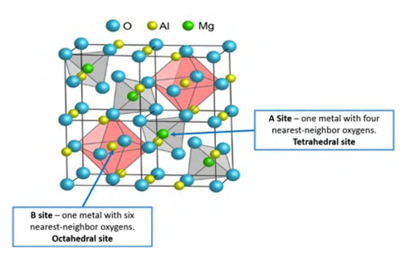
Figure 4: Schematic of the spinel structure of MgAl₂O4
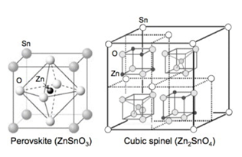
Figure 5: Crystal structures of zinc stannate: perovskite structure for zinc metastannate, (ZnSnO₃) and cubic spinnel structure of zinc orthostannate (ZnSnO₄). A single atom of each element is labeled in the structural diagrams.
Cubic spinels have been assigned to the space group the unit cell of a spinel consists of eight formular units with the oxygen ions forming a closed-packed face centred structure.
3.2.2 Crystal structure—perovskite:
A perovskite is any substance with a crystal structure like that of a mineral known as perovskite. This has calcium titanate oxide(CaTiO3) structure. The perfect cubic structure has the B cation in 6-folds coordination surrounded by an octahedron of anions and the A cations in 12 folds cuboctahedral coordination (Yang, et al., 2015).
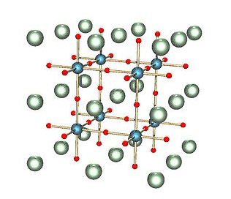
Fig 6: ABX₃ perovskite structure. Here, A, B, and X are white, blue, and red, respectively.

4.0 Doped stannates.
Doping is the deliberate addition of impurities into a material to be able to manage the qualities of the materials. It improves the uniqueness of the material doped eg metal oxide nanoparticles/thin films and enhances its appropriateness for diverse fields. Doping nanomaterials gives a stretchy way to change the qualities of the materials whilst keeping their high surface areas. It is an extensively utilized method for the alteration of nanoparticles to boost their electrical, optical and biological activities. It has been evidenced that doping may enhance the antimicrobial effect
It actually depends on the class of nanomaterial that will comprise the medium. The doping process will vary in case of metallic nanoparticles, oxides or semiconductor (e. g. chalcogenides). Nevertheless, the common trend is to add the doping precursor at the beginning of deposition, before the nucleation of NPs, in the preferred molar ratio and a yield of about 100% is predicted. For metals, the precursors are normally metal salts. For oxides it might be an alcoxide, an organometallic compound or a complex of the transition metal like acetylacetonate. The mechanism of nucleation+ growth for the material is a decrease method (like for metal NPs), a sol-gel process (for oxides) or a thermal decomposition (for some chalcogenides) (Rao & Vanaja, 2015).
Doping diverse elements helps to change and direct the material towards required relaxation properties like electronic, optical, photochemical, photoelectrochemical, photocatalytic and photoexcited properties. The substances can be engineered towards particular usages by cautious choosing of the dopants. Doped nanoparticles, gives the anticipation that doped materials will find applications in optical storage, radiation detection, infrared detection, and dosimetry (Karunakaramoorthy & Suresh, 2014).
The energy structure and physical characteristics of doped nanomaterials plus nanodevices are being affected by quantum size confinement. Near-infrared and up conversion luminescence nanoparticles are particularly hopeful for biological imaging because auto-fluorescence can be overcome and higher imaging resolutions can be obtained. Doped insulator nanomaterials as well as carbon nanotubes signify a new dimension. As a novel kind of biological labeling agent, insulator nanoparticles are less poisonous than semiconductor nanoparticles and are skilled for cancer detection, diagnosis, and treatment. Doped nanomaterials are likely to make central assistance to nanotechnology for practical usages in the fields of electronics, photonics, optics, homeland security, and medical sciences.
5.0 peculiarities/properties of the stannates
The term stannate means compounds of tin (Sn). They are ternary metal oxide semiconductor
The stannates under consideration in this chapter are: Barium stannate (Ba₃SnO), Strontium stannate (SrSnO₃) and Zinc stannate (ZnSnO₄). The BaSnO₃ and SrSnO₃ have perovskite structures while ZnSnO4 has spinel structure. The common formular for the stannate based perovskite type is ASnO₃ while that for spinnel type is ASnO₄ (Raghavan, Schumann, Kim, Zhang, & Stemmer, 2016).
Alkaline-earth metal is any of the six chemical elements that comprise Group 2 (IIa) of the periodic table. The elements are beryllium (Be), magnesium (Mg), calcium (Ca), strontium (Sr), barium (Ba) and radium (Ra). Zinc stannate (ZSO) which is of spinel nature equally belongs to alkaline-earth stannate class like the perovskite natured stannates. It is not a perovskite type but can be an alternative to perovskite substance. It has a non-cubic structure and belongs to R3c space class. Its lattice constant is α=7.758 Å. Barium stannate (BSO) is among the Pm$\overline{3}$m space group. It has α=4.139 Å as its lattice constant. Equally, strontium stannate (SSO) is a member of the Pbnm space class. It has average size of 45 nm. It has lattice constant α=5.709 Å which is pseudocubic.
5.1 Barium Stannate (Barium Stannic oxide), (Barium Tin Oxide), BaSnO₃ (or BSO)
The Barium Stannate is an n-type substance which has cubic perovskite structure with band gap of about 3.4 eV. It maintains stability even at 1000 ⁰C (John, Pillai, Thomas, Joseph, Muthunatesan, & Prabhu, 2017). It is among the Pm$\overline{3}$m space group. It has α=4.139 Å as its lattice constant. Its applications are numerous, they are used as: thermally stable capacitors, humidity sensors, gas sensors, etc. it is also used in optical applications, capacitors, ceramic boundary layers, and equally a promising material to produce gas phase sensors for the detection of carbon monoxide and carbon dioxide (Li, Ma, & Wu, 2017).
The figure below shows the cubic configuration of Barium stannate of Pm$\overline{3}$m class.
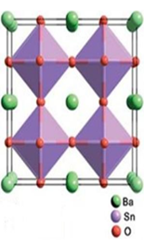
Figure 7: Cubic configuration of Barium stannate of Pm$\overline{3}$m class.
Stibium (Sb) and Lantahnum (La) and other dopants can be used to dope BSO to a highly conductive status. When doped with La, it is called Barium Lantahnum Stannic Oxide (BLSO) which has tremendous metallic conduction as depicted in table 1 below.
Apart from working better due to high mobility, BLSO equally has good stable state for sustenance at elevated thermal conduction (Lee W. , et al., 2017). However, BSO in its epitaxial form has lesser mobility, which actually is contradicting to the very high mobility of BSLO. This is as a result of grain boundaries and dislocation that is causing charge traps and scattering and consequently bringing down the carrier density and mobility at the same time.
When lattice-matched substrate is selected, it will help to lessen dislocation as well as grain boundaries thereby improving dislocation in thin films (Zang, Wang, Sahoo, & Shimada, 2017).
The XRD pattern of BaSnO₃ powder was prepared by solid state reaction method and it presents a polycrystalline nature. X-ray diffraction pattern of the prepared sample presents all the characteristic peaks of cubic phase of BaSnO₃. The inter planar distance ‘d’ of the powder is calculated using Bragg’s relation 2dsinθ=nλ where λ is the wavelength of the X-ray radiation and θ is the diffraction angle. The lattice constant for the compound was calculated and found to be 4.101 Å which is in agreement with the reported value (4.112 Å)¹. The avarage crystallite size D_{(hkl)} of the powder can be calculated using the Debye Scherrer’s formular.
D_{(hkl)}=$\frac{Kλ}{βcosθ}$ ------------------------------------------(eqn 1 )
The average size of the crystallites was found to be 49 nm. This shows the nanocrystalline nature of the powder.

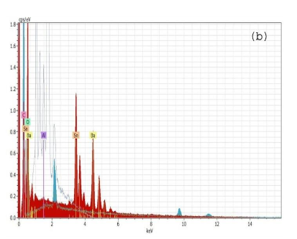
Figur 9: The EDS images of barium stannate deposited via solid state reaction routes
The figure 10 below is a TEM image investigation showing a high resolution of nanostructural and morphological characterization of barium stannate powder. It has particle size of 55 nm which could be calculated from using TEM analysis. This finding corresponds with XRD and SEM analysis. The porousity of the surface morphology having grains of cuboidal structure is also depicted by TEM image.
5.2 Strontium stannate, (Strontium Stannic oxide), (strontium tin oxide), SrSnO₃ (SSO)
Strontium stannic oxide (SrSnO₃) is an n-type material and a perovskite with orthorhombic structure as shown in figure 11 below. It is a member of the Pbnm space class. It has average size
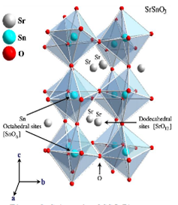
Fig. 11: Orthorhombic arrangement of SSO of Pbnm group.
It is synthesized using solid state reaction, chemical bath, simple wet chemical reaction, electrochemical methods etc. In our work, solid state reaction technique is considered. Commonly, SrSnO₃ powders (for industrial application) is synthesized using solid state reaction. This technique is simple and cheap. Strontium carbonate and titanium dioxde or strontium carbonate (SrCO₃) and tin oxide (SnO₂) which are of high purity, up to 99 % are used as starting marterials. Over 900 ⁰C calcination temperature and a long time is needed in this method. This however has many disadvantages including big particle size with big size distribution and big degree of particle agglomeration. When they are mixed stoichiometrically by ball milling with zirconia media in ethanol for 24 h and later calcined at 1100 ⁰C after drying for 6 h in air, the process produces a uniform, facile, small sized SrSnO₃ powder. The starting materials could be: strontium carbonate (SrCO₃) and tin oxide (SnO₂) which are of high purity, up to 99 % as stated above.

5.3 Zinc Stannate, or Zinc Stannic oxide (ZSO) or Zinc Tin Oxide (ZTO)
ZSO is of spinel structure belonging to alkaline-earth stannate class. It is not a perovskite type but can be an alternative to perovskite substance (Minami, Sonohara, Takata, & Sato, 1994). It has a non-cubic spinel structure which belongs to R3c space class which is depicted in fig.17 below. . Its lattice constant is α=7.758 Å.
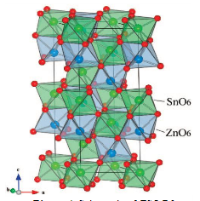
Fig. 17: The spinel structure of a rhombohedral pattern of R3c group
ZTO is an n-type material with an exceptional electronic and optical property. It has spinel non-cubic structure. ZTO has large 3.6 eV and 2.0 values of band gap energy and refractive index respectively. Its larger band gap makes it to have better photostability against UV light than even binary and other stannate components. It is of high-speed charge injection with fast electron flow. It also has soaring electron mobility (10 – 15 Cm²V⁻¹S⁻¹) and finally first-class light-harvesting properties. ZTO metal oxide semiconductor particles are identified for having steady properties under severe situation. They have their use generally in making photo anodes given that they have large surface area and elevated porous structure. This helps in absorbing dye into semiconductor material.
6.0 Preparation/method of synthesis
There are numerous methods used in the fabrication of stannates such as: sol-gel, high temperature solid state reaction, sol-gel combustion, hydrothermal, polymer precursor, spray pyrolysis, lyothermal, wet chemical, chemical precipitation and reverse micelle, magnetic sputtering etc. Out of all these techniques, solid state reaction fabricating means is used in this work together with hydrothermal. This is because it is a better and a convenient technique due to the fact that it is simple, have better mixing of starting materials, have relatively little reaction temperature and simple control of the chemical composition of the end product.
The fig. 22 below show different synthesis methods used in fabrication of thin film stannates and other materi
Fig.23: Common techniques for thin film preparation
Effective deposition of stannates Nanopowders via a chemical or physical route depicts good structure for doping.
6.1 Thin films:
Substances that are made to be thin films are easily integrated into different devices. The uniqueness of such substances significantly vary when they are examined as thin films. The bulk of the working substances are rather important in thin film structure due to some particular properties such as: electrical, magnetic, optical characteristics or wear resistance. In the technology of thin film, there is the utilization of the idea that the properties can habitually checked by the thickness factor. Through deposition processes, thin films are made either by physical or chemical techniques.
6.2 Metal oxide thin films:
Metal oxides are made up of positive metallic and negative oxygen ions. Strong ionic bond is attained when the metallic and oxygen ions are bound by electrostatic interaction. The majority of the metal oxides confirmed outstanding thermal and chemical steadiness. Their several outstanding characteristics resulting from partially or fully filled d-shells help in all kinds of electronic device usages such as solar cells, photoelectrochemical cells, thin film transistors, photocatalysts, and sensors. With reduction in material dimension and bulk up to nanoscale level, this electronic qualities will be improved.

Conclusion
They stannates have varieties of ways that they can be prepared but here the predominant process are solid state reaction and hydrothermal processes. The stannates, typically perovskite-type or spinel-type are utilized in solar cells, (alternative materials, photoanodes, future transparent conductive tool etc ), photocatalysts, etc. Its synthesis improvement is a pointer that its optical as well as electrical performance could be advanced. Doping stannates (which has revealed a significant performance as hopeful) offers a further alternative when doped with the right material. If doped with certain right dopants helps in gettting high electron mobility, making the resistivity which is a reflection of conductivity to be low with high band gap, etc. The incorporation of doped stannates into solar energy harvesting devices helps in solving world energy problems by making the solar cells have a very high functional perfor

REFERENCES:
Agbo, P. E., Nwofe, P. A., Ukwu, C. N., Nweke, F. U., (2016). Effect of dye concentration on doped materials. International Journal of Nanomaterials and chemistry, 2: 1.
Agbo, P. E., Nwofe, P. A., Elekwa, C. A., Nnabuchi, M. N., (2016). Effect of dye concentration on doped materials. International Journal of Nanomaterials and chemistry, 2: 1.
Al-Diabat, M. N., Ahmed M. N., Hashim, M. R., Chahrour, M., Bououdina, M., (2016). Dyed samples. Procedia Chemistry, 19: 485.
Augustine, C.N. (2007). Band gap determination of chemically deposited lead sulphide based
heterojunction films. Journal of Non-Oxide Glasses, 9 (3): 85—98.
Augustine, C. and Nnabuchi, M. (2016). The electrical and optical characteristics of Sb-doped and annealed nanocrystalline SnO₂ thin films deposited in CBD techniques. Journal of Ovonic Research, 11 (6): 285—291.
Augustine, C., Chikwenze, R., and Anyaegbunam, F. (2019). Comparative investigation of some selected properties of Mn₃O₄ and CuO/PbS composite thin films. Material Research Express (online), 51: 43—52.
Barry, B.W., Edwards, H.G.M., Williams, A.C. (1992). Fourier transform raman and infrared vibrational study of human skin: Assignment of spectral bands (1992). Journal of Raman Spectroscopy23 (11): 641—645.
Bown, D.F., Pardo, H., Mombru, A.W. (2019). The crystal structures of stannates and titanates thin films deposited using sol-gel method. Journal of Chemical Engineering, 76: 234—241.
Chang, Y.S, Chang Y.H., Chen, I.G., Chen, G.J., Chai, Y.L.,Fang, T.H., Wu, S. (2004). Synthesis, formation and characterization of ZnTiO₃. Ceramic International, 30: 2183—2189.
Chen, D., and Ye, J. (2007). SrSnO₃ nanostructured synthesis, characterization and photocatalytic properties. Photocatalytic Material Center, National Institute of Materials Science (NIMS), 19: 4585—459.
El-Shishtway, R.M. (2009). Functional dyes and some Hi-tech applications. International Journal of Photoenergy, 1(21):434-441
Energy information administration. (2011). U.S Energy Information Administration. Retrieved march
10, 2021, from international energy statistics: www.eia.go/cfapps/ipdproject/IEDIndex3.cfn.
Ezema, F.I. (2004). Fabrication, optical properties and applications of undoped chemical bath deposited ZnO thin films. Journal of Material Science: Materials in Electronics, 15: 343—350.
Faccio, R., Fernandez-Werner, L., Pardo, H., Mombru, A.W. (2011). Current trends in materials for dye-sensitized solar cells. Recent Patents on Nanotechnology, 5: 46—61.
Kim, D.R., Hwang, D., Son, C.S., Son, Y.G. (2017). The influence of Dye on the energy band gap of materials. Journal of Nanoscience and Nanotechnology, 7: 5016.
Kumarasinghe, P.K.K., Dissanayake, A., Pemasiri, B.M.K., and Dassanayake, B.S. (2017). Effect of post deposition heat treatment on microstructure parameters, optical constants and composition of thermally evaporated CdTe thin films. Mater. Sc. Semicond. Process, 58: 51—62.
Lana-Villarreal, T.E., Boschioo, G., Hagfeldt, A. (2007). Nanostructured zinc stannate as semiconducror working electrodes. J. Phys. Chem., 111: 5549—5556.

